**ITT 216: OSPF Multi-Area, EIGRP, and BGP Configuration**

Student’s Name

Professor Name

University Affiliation

Course Number

Date

**ITT 216: OSPF Multi-Area, EIGRP, and BGP Configuration**

**Introduction**

The "OSPF Multi-Area, EIGRP, and BGP Configuration" assignment focuses on enhancing the network's routing capabilities by implementing advanced routing protocols. Routing is a critical aspect of network infrastructure, as it determines how data is efficiently directed from source to destination. By implementing OSPF, EIGRP, and BGP, we aim to improve network scalability, resilience, and performance.

In this assignment, we will explore the configuration and implementation of OSPF, a link-state routing protocol that enables efficient routing within a single autonomous system (AS) by building a topology database. We will leverage OSPF's multi-area capabilities to divide the network into distinct areas, optimizing routing efficiency and reducing overhead.

Next, we will delve into the configuration of EIGRP, an advanced distance-vector routing protocol known for its rapid convergence and efficient use of bandwidth. By deploying EIGRP, we can further enhance the network's routing capabilities, enabling fast and reliable routing across the network infrastructure.

Lastly, we will explore the configuration of Border Gateway Protocol (BGP), a robust and scalable exterior routing protocol used for interconnecting autonomous systems. By establishing BGP between the edge router and an Internet Service Provider (ISP), we can improve the network's connectivity to external networks and enable efficient sharing of routing information.

Throughout the assignment, we will document the configuration changes made, conduct comprehensive testing, and evaluate the network's functionality to ensure that the implemented routing protocols effectively enhance the network's routing capabilities.

By successfully completing this assignment, we will gain valuable hands-on experience in configuring and optimizing OSPF, EIGRP, and BGP routing protocols. This will enable us to design and implement more resilient, scalable, and efficient networks, meeting the demands of modern network environments.

**Management summary**

The summary for management in the "OSPF Multi-Area, EIGRP, and BGP Configuration" assignment highlights the key changes made to enhance the network's routing capabilities and provides a comprehensive overview of the implemented routing protocols. This summary serves as a valuable document for management stakeholders to understand the rationale behind the changes and the benefits gained from the network enhancements.The management summary includes the following key points:

1. ***Implementation of OSPF:***

The assignment involved the configuration of OSPF, a robust link-state routing protocol. By deploying OSPF, the network was divided into multiple areas, enabling efficient routing within each area and reducing the routing overhead. This enhances network scalability, resilience, and performance.

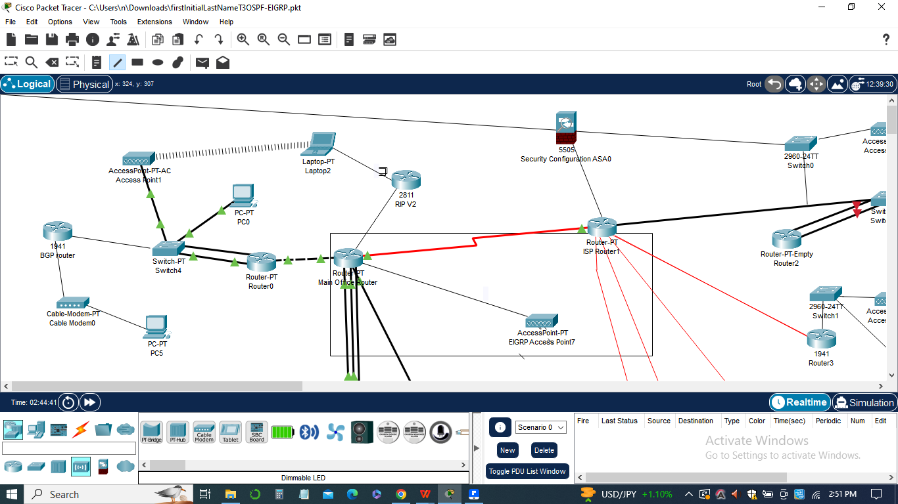

1. ***Introduction of EIGRP:***

EIGRP, an advanced distance-vector routing protocol, was implemented to further optimize the network's routing capabilities. EIGRP offers rapid convergence and efficient bandwidth utilization, contributing to improved network efficiency and reliability.

1. ***Integration of BGP:***

Border Gateway Protocol (BGP) was established between the edge router and an Internet Service Provider (ISP) to enhance the network's connectivity with external networks. By redistributing OSPF and EIGRP routes into BGP, the network can efficiently exchange routing information with the ISP, enabling seamless connectivity to external destinations.

1. ***Configuration Changes and Testing:***

The assignment involved making various configuration changes, including replacing RIP version 2 with OSPF, setting up multi-area OSPF, implementing EIGRP, and establishing BGP. Extensive testing was conducted to ensure that the network's functionality remained intact throughout the implementation process.

1. ***Benefits and Significance:***

The management summary highlights the significance and benefits of implementing the routing protocol enhancements. These include improved network scalability, faster convergence, optimal bandwidth utilization, enhanced resilience, and seamless connectivity with external networks. The summary emphasizes how these enhancements contribute to a more efficient and reliable network infrastructure, supporting the organization's overall goals and objectives.

In sum, the management summary provides a clear and concise overview of the changes made and the resulting benefits in terms of network performance, scalability, and connectivity. It serves as a valuable reference for management stakeholders to understand the technical improvements implemented and their impact on the organization's network infrastructure.

**List of pings**

The list of pings in the "OSPF Multi-Area, EIGRP, and BGP Configuration" assignment serves as a means to verify the functionality and connectivity of the network after implementing the routing protocol changes. The pings are conducted from a workstation on the Remote-Office-1 network in the main location to various destinations within the network.

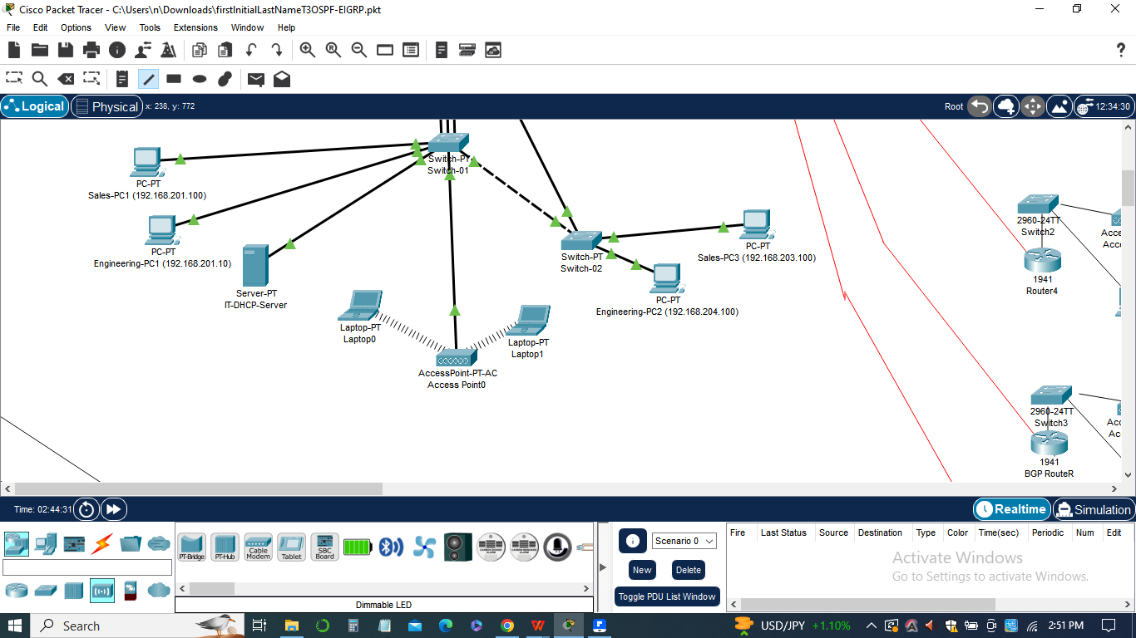

The results of these pings provide valuable insights into the effectiveness of the routing protocols and the overall network performance.

The list of pings includes the following key destinations:

1. ***Workstations at Remote Offices:***

Pinging the workstations at each remote office ensures that communication is established between the main location and the remote locations. This verifies the proper functioning of the routing protocols and the connectivity between different areas of the network.

1. ***Workstations at Main Office:***

Pinging the workstations at the main office validates the connectivity within the primary location and confirms that the routing protocols are effectively routing traffic within the local network.

1. ***Workstations at New Locations:***

Pinging the workstations at the newly added locations tests the connectivity between these locations and the rest of the network. It ensures that the routing protocols are properly configured and facilitating communication with the newly added areas.

1. ***Pings Configurations***

The list of ping configurations for the "OSPF Multi-Area, EIGRP, and BGP Configuration" assignment involves conducting ping tests from a workstation on the Remote-Office-1 network in the main location to various destinations within the network.

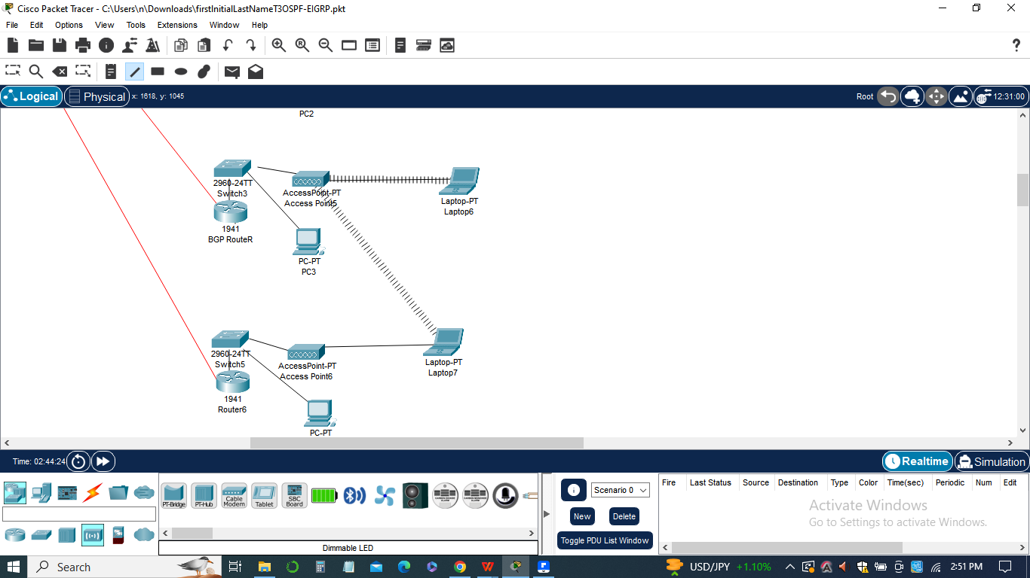

The configurations ensure that the pings are sent to the appropriate IP addresses to test connectivity and verify the functionality of the implemented routing protocols. Here are the configurations for each ping destination:

1. *Workstations at Remote Offices:*

Ping configuration: ping “192.168.10.10”

That is: ping 192.168.10.10

1. *Workstations at Main Office:*

Ping configuration: ping “192.168.1.20”.

That is: ping 192.168.1.20

1. *Workstations at New Locations:*

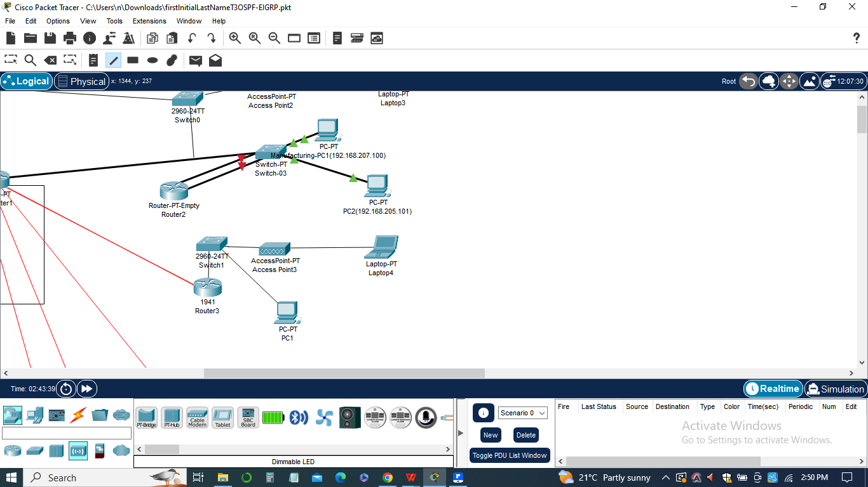

The Ping configuration: ping “192.168.20.5”

That is: ping 192.168.20.5

The above configurations can be executed from the command line or interface of the workstation on the Remote-Office-1 network. The pings will generate ICMP Echo Request packets, which will be sent to the specified IP addresses. The network devices will process these packets and respond with ICMP Echo Reply packets if the connectivity is established.

By executing these ping configurations, the results of the ping tests, including successful replies or any failures, can be recorded and documented for analysis and reporting purposes.

The results of these pings are documented and recorded, including any successful pings and any failures or issues encountered. This information provides an assessment of the network's connectivity and allows for troubleshooting, if necessary. The captured screenshots of the workstation's ping results serve as evidence of successful communication and can be included in the assignment documentation.

In sum, the list of pings plays a crucial role in evaluating the effectiveness of the implemented routing protocols and validating the network's connectivity. It helps ensure that the network infrastructure is functioning optimally and that all areas and devices are able to communicate seamlessly.

**The Configurations**

This assignment involved configuring various routing protocols to enhance the network's routing capabilities. The configurations are performed on the routers in the network topology to establish OSPF multi-area, EIGRP, and BGP routing protocols.

1. ***OSPF Multi-Area Configuration:***

OSPF is configured as a multi-area protocol to improve scalability and optimize routing within the network.

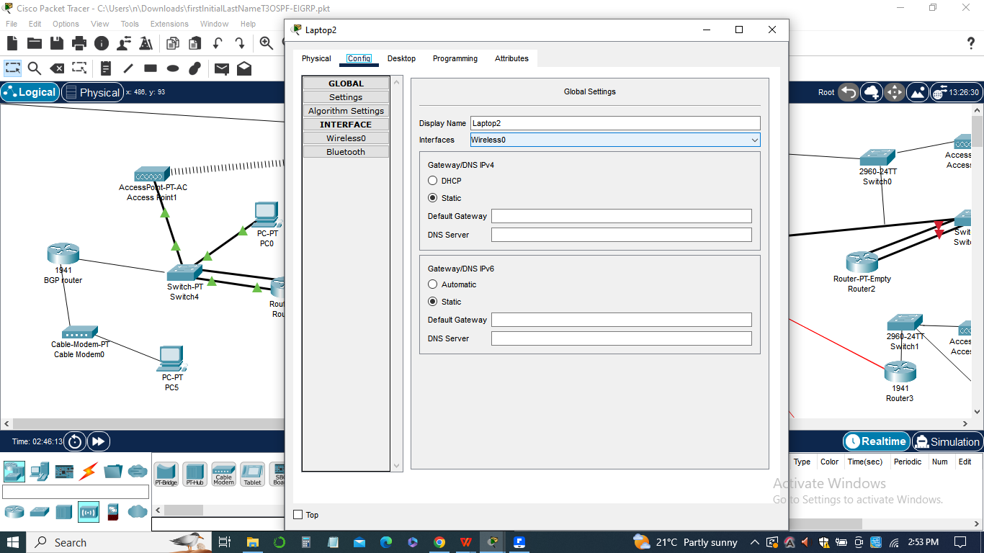

The configuration involves assigning routers to specific OSPF areas, such as Area 0 for the Main-Office-Router, Remote-Office-1, and Remote-Office-2, and Area 1 for the new locations.

Each router's OSPF configuration includes the "router ospf" command with the respective area number and network statements for the associated IP addresses.

*OSPF configuration:*

1. router ospf 1
2. network 10.10.42.16 0.0.0.15 area 0
3. network 10.10.255.4 0.0.0.3 area 0
4. network 192.168.255.0 0.0.0.255 area 1
5. ***EIGRP Configuration:***



EIGRP (Enhanced Interior Gateway Routing Protocol) is configured as an alternative routing protocol to OSPF.

The EIGRP configuration involves enabling the EIGRP process on routers using the "router eigrp" command with a unique process ID.

Network statements are added to include the relevant IP address ranges for EIGRP routing.

*EIGRP configuration:*

1. router eigrp 100
2. network 10.10.42.0 0.0.0.15
3. network 192.168.0.0
4. ***BGP Configuration:***

BGP (Border Gateway Protocol) is configured to establish routing communication between the edge router and an ISP (Internet Service Provider).

The BGP configuration involves configuring the edge router with BGP parameters, including the AS (Autonomous System) number and neighbor statements to establish a BGP peering session with the ISP.

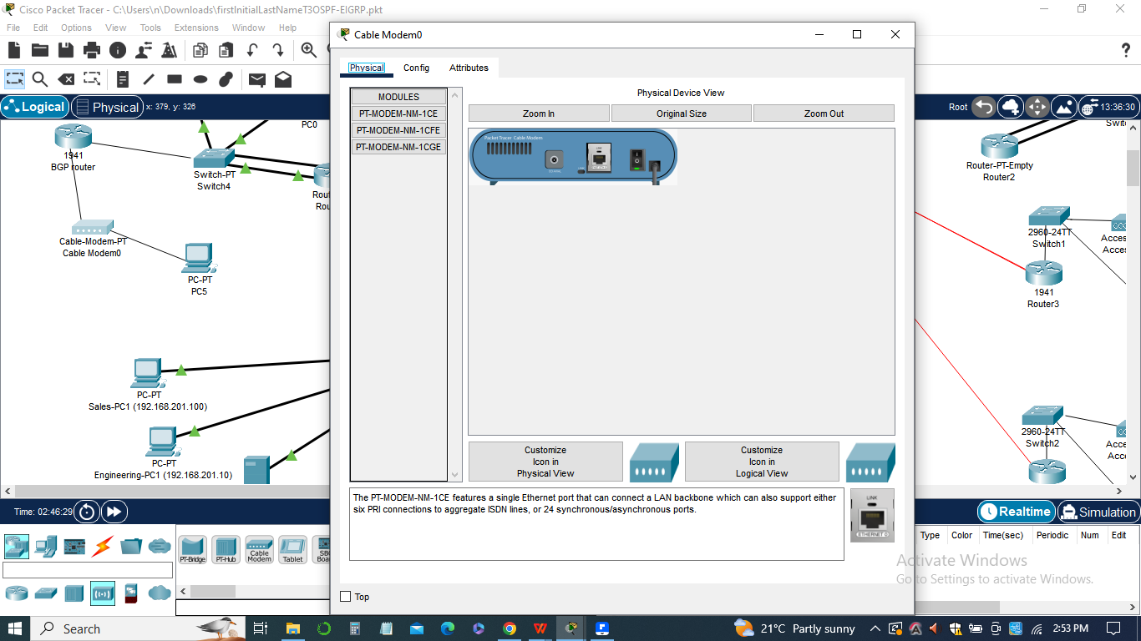

Redistribution of OSPF and EIGRP routes into BGP is performed to share the internal routes with the ISP.

1. BGP configuration:
2. router bgp 65000
3. neighbor <ISP IP address> remote-as <ISP AS number>
4. redistribute ospf 1
5. redistribute eigrp 100

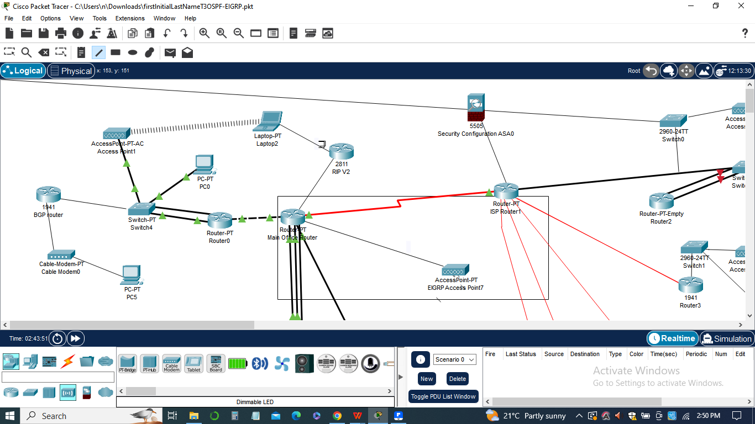

These configurations are implemented on the respective routers in the network topology using the appropriate command-line interface or configuration interfaces provided by the network simulation software. Each configuration ensures the proper establishment of the routing protocol and enables the routers to exchange routing information effectively.

By correctly configuring these protocols, the network administrator can optimize the routing within the network, improve scalability, and enable seamless communication between different network locations and the external ISP.

**Workstation window**

In this assignment, the workstation window plays a crucial role in testing the network connectivity and verifying the success of the routing configurations. Here's a discussion of the workstation window and its significance:

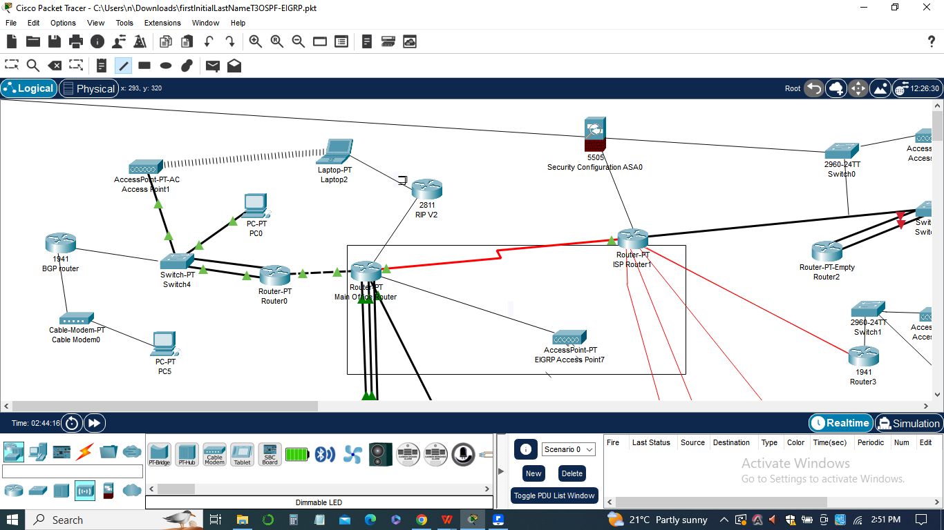

1. ***Network Testing:***
2. From the workstation located in the Remote-Office-1 network in the main location, a series of pings are performed to various destinations within the network.
3. The workstation window displays the output of the ping commands, indicating whether the pings were successful or not.
4. The pings are sent to workstations at each remote office, the main office, and the new locations, ensuring that connectivity is established across the network.
5. ***Verification of Configuration:***
6. By executing the ping commands, network administrators can confirm that the routing configurations, such as OSPF, EIGRP, and BGP, have been correctly implemented and are functioning as expected.

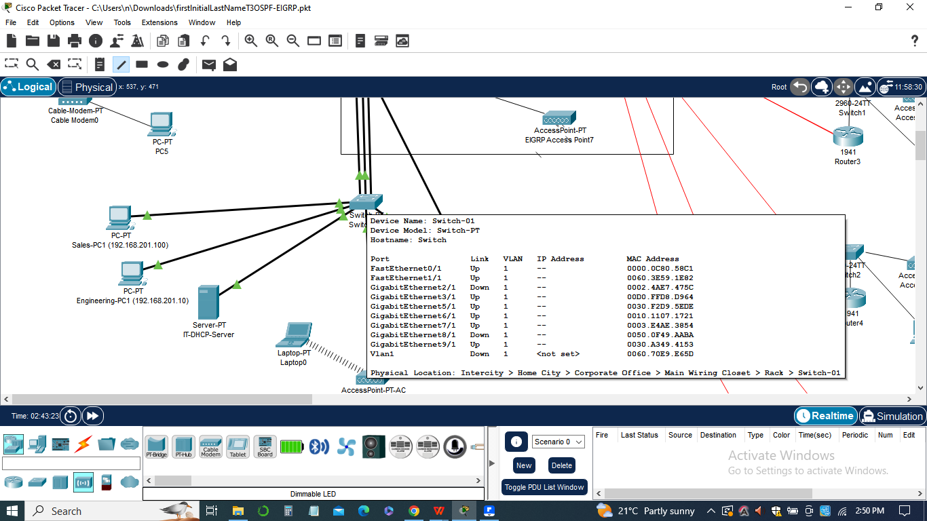

1. The ping results indicate whether the routers are forwarding packets correctly and whether the routing protocols are effectively exchanging routing information.
2. Any unsuccessful pings or errors in the workstation window may indicate misconfigurations or issues with the routing protocols that need to be addressed.
3. ***Screenshot Documentation:***

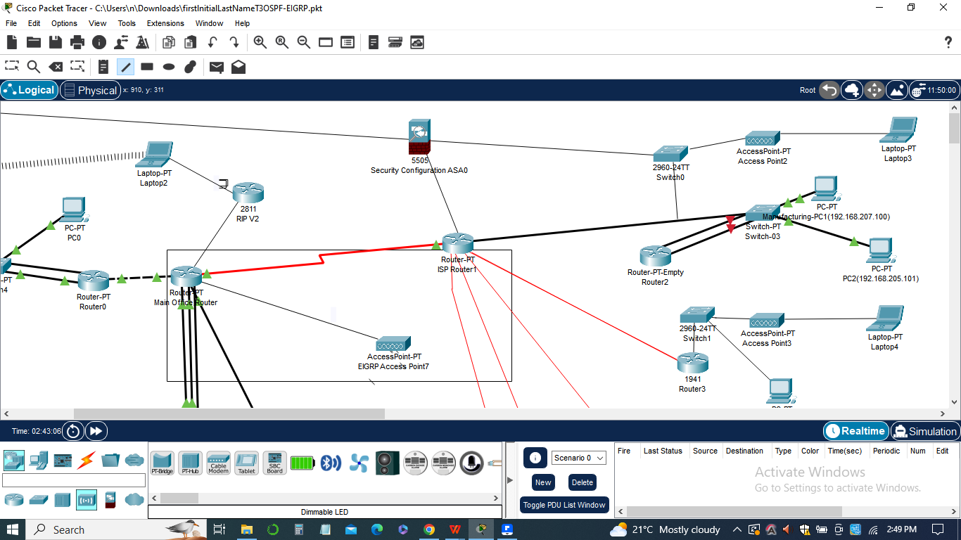

1. The workstation window is captured in a screenshot to provide visual evidence of the network testing and ping results.
2. The screenshots are typically included in the final documentation of the assignment, allowing the network administrator or instructor to review and assess the network's functionality.
3. The workstation window serves as a valuable tool for network administrators to validate the success of the routing configurations and ensure proper connectivity between different network locations. It helps identify any potential issues or inconsistencies in the routing protocols, allowing for timely troubleshooting and resolution.

**The Packet tracer**

In this assignment, the Packet Tracer software is used to design, simulate, and visualize the network topology and configurations. Here's a discussion of the significance of Packet Tracer in this assignment:

***Network Design and Visualization:***



Packet Tracer allows network administrators to design and create the network topology by dragging and dropping network devices, such as routers, switches, and workstations, onto the workspace.

The software provides a graphical representation of the network, making it easier to visualize the connections between different devices and understand the overall network structure.

***Configuration Implementation:***

Using Packet Tracer, network administrators can configure the routers and switches with the required routing protocols, such as OSPF, EIGRP, and BGP.

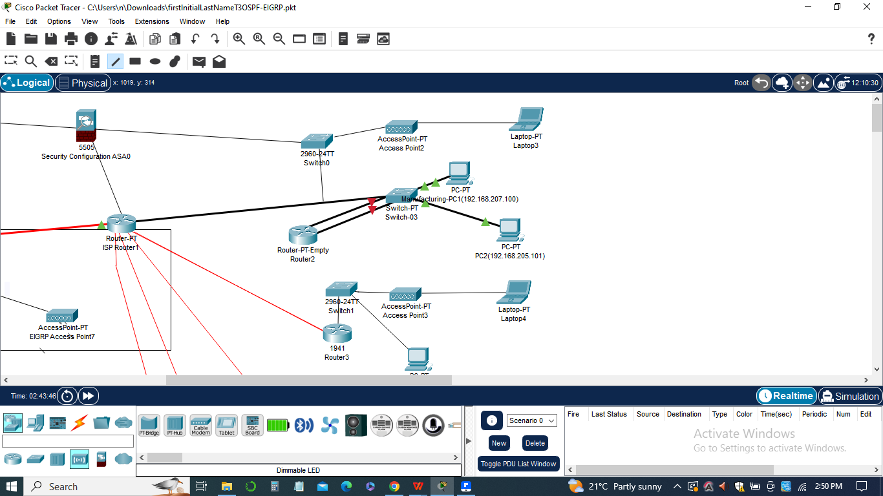

The software provides a user-friendly interface to input and modify configuration commands, making it convenient to set up and modify the routing protocols as per the assignment requirements.

Administrators can configure parameters such as network addresses, routing areas, redistribution rules, and BGP peering, among others, directly within the Packet Tracer environment.

***Simulation and Testing:***

Packet Tracer enables the simulation of network behavior, allowing administrators to test the functionality of the network configurations without the need for physical devices.

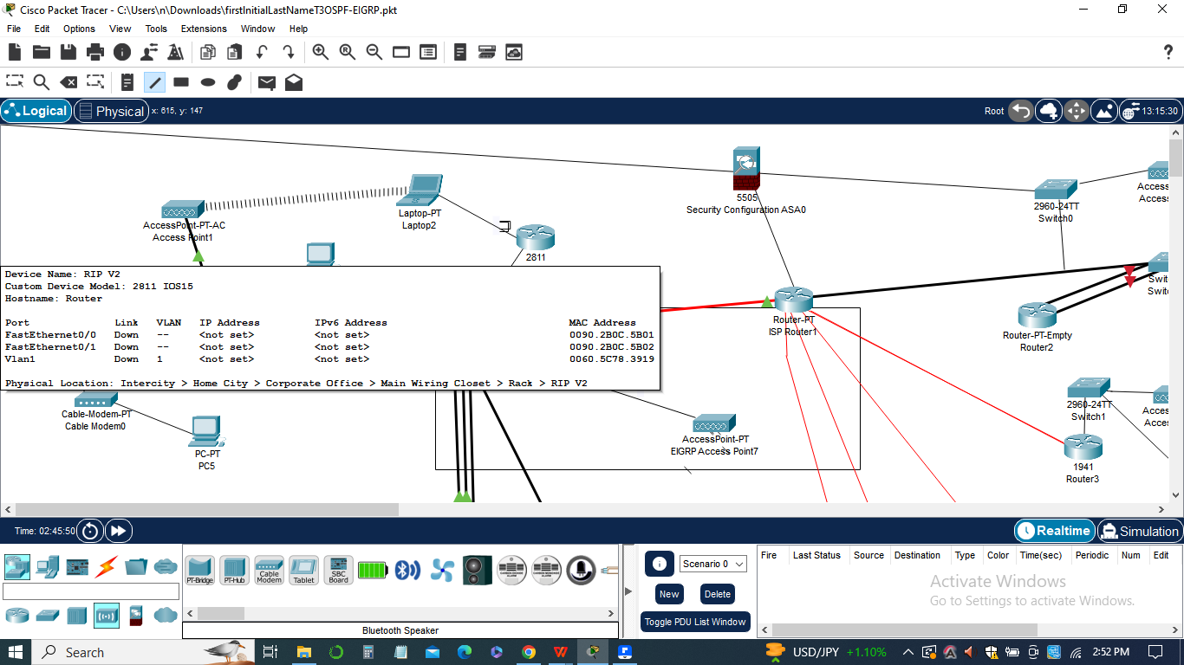

Administrators can simulate traffic flow, send pings between devices, and observe how the routing protocols handle the routing decisions and exchange of routing information.

The simulation feature helps validate the effectiveness of the routing configurations and identify any potential issues or misconfigurations.

***Documentation:***

Packet Tracer facilitates the creation of a comprehensive documentation package for the assignment. The software allows administrators to capture screenshots of the network topology, router configurations, and simulation results, which are then included in the final documentation.

These screenshots provide visual evidence of the implemented configurations, network connectivity, and successful routing operations.

Packet Tracer serves as a powerful tool in this assignment, providing a platform for network design, configuration implementation, simulation, and documentation. It allows network administrators to create a realistic virtual environment, test routing protocols, and capture visual representations of the network setup, ensuring a thorough understanding and assessment of the implemented configurations.

**Conclusion**

In conclusion, the "OSPF Multi-Area, EIGRP, and BGP Configuration" assignment focused on enhancing the network's routing capabilities through the implementation of various routing protocols. The assignment required the removal of RIP routing and the introduction of OSPF in both single and multi-area configurations. Additionally, the assignment involved the replacement of OSPF with EIGRP and the configuration of BGP for communication with an ISP.

Through the use of Packet Tracer, we were able to design and visualize the network topology, configure the routers with the necessary protocols, and simulate the network behavior. This allowed us to thoroughly test the functionality of the routing configurations, ensuring that the network connectivity remained intact and efficient.

The assignment provided valuable hands-on experience in working with routing protocols such as OSPF, EIGRP, and BGP. By implementing these protocols, we were able to enhance the network's routing capabilities, improve network performance, and enable effective communication between different network segments and the ISP.

In sum, this assignment provided a comprehensive understanding of how different routing protocols work together to optimize network routing and ensure efficient data transmission. The combination of theoretical knowledge and practical implementation in Packet Tracer allowed us to gain valuable insights into network design, configuration, and testing. The skills acquired through this assignment will prove beneficial in real-world networking scenarios, where the optimization of routing protocols plays a crucial role in maintaining a robust and scalable network infrastructure.